Practical 7:-

Canny Edge

import cv2

import numpy as np

import pandas as pd

import matplotlib.pyplot as plt

img=cv2.imread("assets/tiger.jpg",cv2.IMREAD_GRAYSCALE)

#cv2.imshow('original',img)

# assert img is not None: "file could not read"

edges=cv2.Canny(img,100,200)

#print(img.shape)

plt.subplot(121), plt.imshow(img,cmap='gray')

plt.title('orginal image'),plt.xticks([]),plt.yticks([])

plt.subplot(122),plt.imshow(edges,cmap='gray')

plt.title('Edge image'),plt.xticks([]),plt.yticks([])

plt.show()

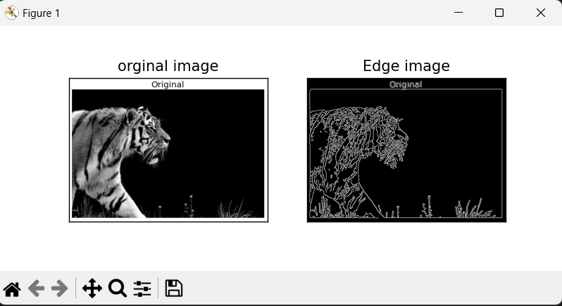

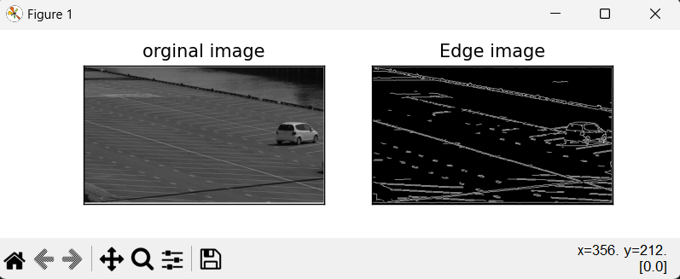

Hough Filter:-

import cv2

import numpy as np

img=cv2.imread('assets/parking_lot.jpg')

gray=cv2.cvtColor(img,cv2.COLOR_BGR2GRAY)

edges=cv2.Canny(gray,75,150)

lines=cv2.HoughLinesP(edges,1,np.pi/180,30,maxLineGap=250)

for line in lines:

    x1,y1,x2,y2=line[0]

    cv2.line(img,(x1,y1),(x2,y2),(0,0,128,1))

cv2.imshow("LinesEdges ",edges)

cv2.imshow("LinesDetected ",img)

cv2.waitKey(0)

cv2.destroyAllWindows()

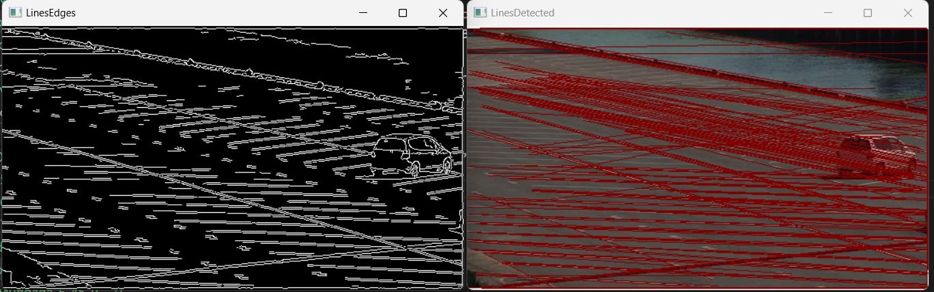

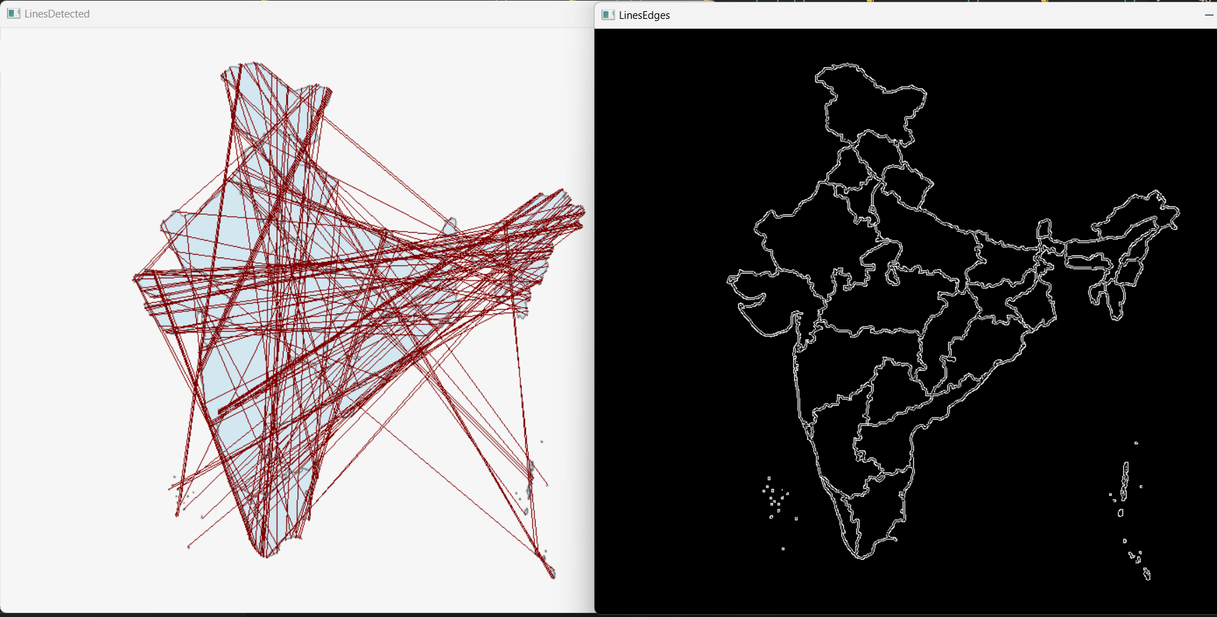

Practical 8

Video Properties:-

# importing cv2

import cv2

# For Video File

capture=cv2.VideoCapture(r"assets\video.mp4")

# For webcam

#capture = cv2.VideoCapture(0)

# showing values of the properties

print("CV_CAP_PROP_FRAME_WIDTH: '{}'".format(capture.get(cv2.CAP_PROP_FRAME_WIDTH)))

print("CV_CAP_PROP_FRAME_HEIGHT : '{}'".format(capture.get(cv2.CAP_PROP_FRAME_HEIGHT)))

print("CAP_PROP_FPS : '{}'".format(capture.get(cv2.CAP_PROP_FPS)))

print("CAP_PROP_POS_MSEC : '{}'".format(capture.get(cv2.CAP_PROP_POS_MSEC)))

print("CAP_PROP_FRAME_COUNT  : '{}'".format(capture.get(cv2.CAP_PROP_FRAME_COUNT)))

print("CAP_PROP_BRIGHTNESS : '{}'".format(capture.get(cv2.CAP_PROP_BRIGHTNESS)))

print("CAP_PROP_CONTRAST : '{}'".format(capture.get(cv2.CAP_PROP_CONTRAST)))

print("CAP_PROP_SATURATION : '{}'".format(capture.get(cv2.CAP_PROP_SATURATION)))

print("CAP_PROP_HUE : '{}'".format(capture.get(cv2.CAP_PROP_HUE)))

print("CAP_PROP_GAIN  : '{}'".format(capture.get(cv2.CAP_PROP_GAIN)))

print("CAP_PROP_CONVERT_RGB : '{}'".format(capture.get(cv2.CAP_PROP_CONVERT_RGB)))

# release window

capture.release()

cv2.destroyAllWindows()

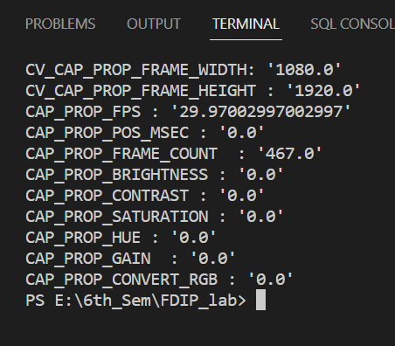

VideoProcess:-

import cv2

# Create a video capture object, in this case we are reading the video from a file

vid_capture = cv2.VideoCapture(r"assets\video.mp4")

if (vid_capture.isOpened() == False):

    print("Error opening the video file")

# Read fps and frame count

else:

    # Get frame rate information

    # You can replace 5 with CAP_PROP_FPS as well, they are enumerations

    fps = vid_capture.get(5)

    print('Frames per second : ', fps, 'FPS')

    # Get frame count

    # You can replace 7 with CAP_PROP_FRAME_COUNT as well, they are enumerations

    frame_count = vid_capture.get(7)

    print('Frame count : ', frame_count)

while (vid_capture.isOpened()):

    # vid_capture.read() methods returns a tuple, first element is a bool

    # and the second is frame

    ret, frame = vid_capture.read()

    if ret == True:

        # Resize the frame to 640x480

        resized_frame = cv2.resize(frame, (640, 480))

        cv2.imshow('Frame', resized_frame)

        # 20 is in milliseconds, try to increase the value, say 50 and observe

        key = cv2.waitKey(20)

        if key == ord('q'):

            break

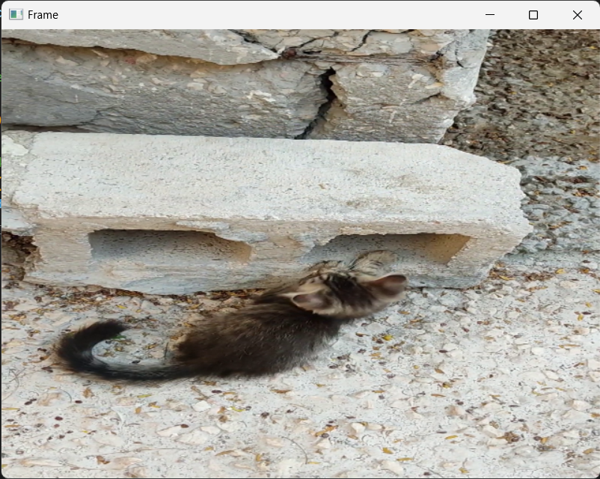    else:

        break

# Release the video capture object

vid_capture.release()

cv2.destroyAllWindows()

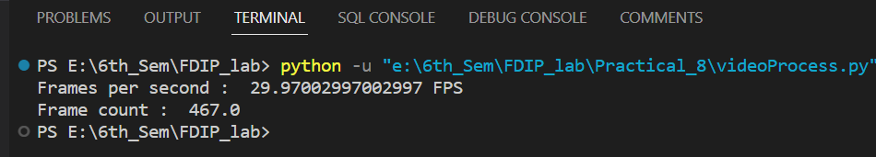

Video Save:-

# Python program to save a video using OpenCV

import cv2

# Create an object to read from camera

video = cv2.VideoCapture(r"assets\video.mp4")

# We need to check if camera is opened previously or not

if (video.isOpened() == False):

    print("Error reading video file")

# We need to set resolutions. so, convert them from float to integer.

frame_width = int(video.get(3))

frame_height = int(video.get(4))

size = (frame_width, frame_height)

# Below VideoWriter object will create a frame of above defined The output

# is stored in 'filename.avi' file.

result = cv2.VideoWriter('filename.avi',cv2.VideoWriter_fourcc(*'MJPG'),10, size)

while (True):

    ret, frame = video.read()

    if ret == True:

        # Write the frame into the

        # file 'filename.avi'

        result.write(frame)

        # Display the frame saved in the file

        frame = cv2.resize(frame, (640, 480))

        cv2.imshow('Frame', frame)

        # Press S on keyboard to stop the process

        if cv2.waitKey(1) & 0xFF == ord('s'):

            break

    # Break the loop

    else:

        break

# When everything done, release the video capture and video write objects

video.release()

result.release()

# Closes all the frames

cv2.destroyAllWindows()

print("The video was successfully saved")

